Alone again Naturally
Gilbert O’Sullivan
In a little while from now
If I’m not feeling any less sour
I ( ) myself to treat myself
And visit a nearby tower
And climbing to the top will throw myself off
In an ( ) to make it clear to who
Ever what it’s like when you’re shattered
Left standing in the lurch at a church
Where people are saying: "My God, that’s tough
She's stood him up"
No ( ) in us remaining
We may as well go home
As I did on my own
Alone again, naturally
To think that only yesterday
I was ( ), bright and gay
Looking forward to well wouldn’t do
The role I was about to play
But as if to knock me down
Reality came around
And without so much, as a mere touch
Cut me into little ( )
Leaving me to doubt
Talk about God and His mercy
Or if He really does exist
Why did He desert me in my hour of need
I truly am ( ) Alone again, naturally
It seems to me that there are more hearts
( ) in the world that can’t be mended
Left unattended
What do we do? What do we do?
Alone again, naturally
Now looking back over the years
And whatever else that ( )
I remember I cried when my father died
Never wishing to hide the tears
And at sixty-five years old
My mother, God rest her soul,
Couldn’t ( ) why the only man
She had ever loved had been taken
Leaving her to start with a heart so badly broken
( ) encouragement from me
No words were ever spoken
And when she passed away
I cried and cried all day
Alone again, naturally
Alone again, naturally

We are the Champions
Queen
I've paid my dues -
Time after time -
I've done my ( )
But committed no crime -
And bad ( )
I've made a few
I've had my share of sand kicked in my face
But I've come through
Refrain:
We are the champions - my friends
And we'll keep on( ) - till the end -
We are the champions -
We are the champions
No time for losers
'Cause we are the champions - of the world -
I've taken my bows
And my curtain calls -
You ( ) me fame and ( ) and everything that goes with it, I thank you all -
But it's been no bed of roses
No pleasure cruise -
I consider it a ( ) before the whole human race -
And I ain't gonna lose -
(refrain)
For Good
(Elphaba):
I’m limited
Just look at me – I’m limited
And just look at you
You can do all I couldn't do,
Glinda
So now it's up to you
For both of us –
now it's up to you...
(Glinda):
I've heard it said
That people come into our lives for a ( )
Bringing something we must learn
And we are led
To those who help us most to grow
If we let them
And we help them in return
Well, I don't know if I ( ) that's true
But I know I'm who I am today
Because I knew you...
Like a comet pulled from orbit
As it ( ) a sun
Like a stream that meets a boulder
Halfway through the wood
Who can say if I've been changed for the better?
But because I knew you
I have been changed for good
(Elphaba):
It well may be
That we will never meet again
In this ( )
So let me say before we part
So much of me
Is made from what I ( ) from you
You'll be with me
Like a handprint on my heart
And now whatever way our ( ) end
I know you have re-written mine
By being my friend...
Like a ship blown from its mooring
By a wind off the sea
Like a seed ( ) by a skybird
In a distant wood
Who can say if I've been changed for the better?
But because I knew you
(Glinda):
Because I knew you
(Both):
I have been changed for good
(Elphaba):
And just to clear the air
I ask forgiveness
For the things I've done you blame me for
(Glinda):
But then, I guess we know there's blame to share
(Both):
And none of it seems to matter anymore

(Glinda):  Like a comet pulled from orbit  As it ( ) a sun Like a stream that meets a boulder  Halfway through the wood | (Elphaba):  Like a ship blown from its mooring  By a wind off the sea  Like a seed ( ) by a bird in the wood

(Both):
Who can say if I've been changed for the better?
I do believe I have been changed for the better
(Glinda):
And because I knew you...
(Elphaba):
Because I knew you...
(Both):Because I knew you...I have been changed for good..
You were meant for me
Jewel

I hear the clock, it's six am
I feel so far from where ____ _____
I got my eggs, I got my pancakes, too
I've got my maple syrup. Everything but you.

I break the yolks and make a smiley face.
I kind of like in my brand new _____
wipe the spots off of the mirror,
don't ______ my keys in the door.
I never put wet _____on the floor anymore cuz,

(chorus)
dreams last so long
even after you're _________
I know that you ______ ______
and _____ you will see.
You were _____ for me and I was____ ___ ___.

I called my mama she was ___ ____ a walk
consoled a cup of coffee, but it didn't want to talk
so I Picked up the paper it ___ _____ bad news.
More _____ ______ ______, more people being used

I put on my _____t in the pouring rain,
I saw ______ it just ________ the same,
cuz it was ______ oh I was _____ and
It made me ____ _____, oh so bad, cuz

Repeat chorus

I go about my _______, i'm doing fine
besides what would I say if I had you __ the line.
same old _______, not much to say
_______ are broken every day.

I brush my ______ I put the cap back __
I know you ____ __ when I leave the _______ on
I pick a _____ ___ and I turn the sheets _____
and I take a deep ______ and a good look around

I put on my PJs and hop into bed
I'm half ______ but I feel mostly _____
I try and _____ ______ it'll all be alright
I just shouldn't think any _____ _______

Repeat chorus

Fallin'
Alicia Keys

I keep on fallin ___and ____ Of love
With you
Sometimes I love you
Sometimes you _______ me _____
Sometimes I feel good
At times I feel used
Lovin you darlin makes me so ____
Hook:
I keep on fallin ___ and ___ of love With you
Ive never
____ ______ Way that I Love you
Oh, oh ive ______ felt this way
__ do you give me so much pleasure
And _____ me so much _____
Just when I think
Ive takin more than would a ____
I start falling Back in love with you
Hook
Bridge:
Now baby I,i,i,i'm Fallin I,i,i,i'm Fallin
Fall,fall,fallin
Hook 3xs
Yellow
ColdPlay

Look ( ) the stars
Look how they shine ( ) you
And everything you do
Yeah they were all yellow
I came ( )
I wrote a song for you
And all the things you do
And it was called yellow
So then I ( ) my turn
Oh what a thing to have done
And it was all yellow
Your skin
Oh yeah your skin and bones
Turn( ) something beautiful
You know you know I love you so
You know I love you so
I swam ( )
I jumped ( ) for you
Oh what a thing to do
Cause you were all yellow
I drew a line
I drew a line for you
Oh what a thing to do
And it was all yellow
Your skin
Oh yeah your skin and bones
Turn ( )into something beautiful
And you know
For you I'd bleed myself dry
For you I'd bleed myself dry
It's true
Look how they shine( ) you
Look how they shine( ) you
Look how they shine( )
Look how they shine( ) you
Look how they shine( ) you
Look how they shine
Look ( ) the stars
Look how they shine ( ) you
And all the things ( )you do
Don’t Know Why
Norah Jones

I waited 'til I saw the sun
I don't know why I ( ) come
I left you by the house of fun
I don't know why I ( ) come
I don't know why I ( ) come
When I saw the break of day
I wished that I ( ) fly away
Instead of kneeling in the sand
Catching teardrops in my hand
My heart is drenched in wine
But you'll be ( ) my mind
Forever
Out ( ) the endless sea
I would die in ecstasy
But I'll be a bag of bones
Driving down the road alone
My heart is drenched in wine
But you'll be ( ) my mind
Forever
Something has to make you run
I don't know why I ( ) come
I feel as ( ) as a drum
I don't know why I ( ) come
I don't know why I ( ) come
Reductions
example sentence, “I don't want to go the the park with him,”
--ai dont wɔnt tu gəu tu ðə park wɪɵ hɪm
--ai don wɔnə gəu tə də park wɪt ɪm
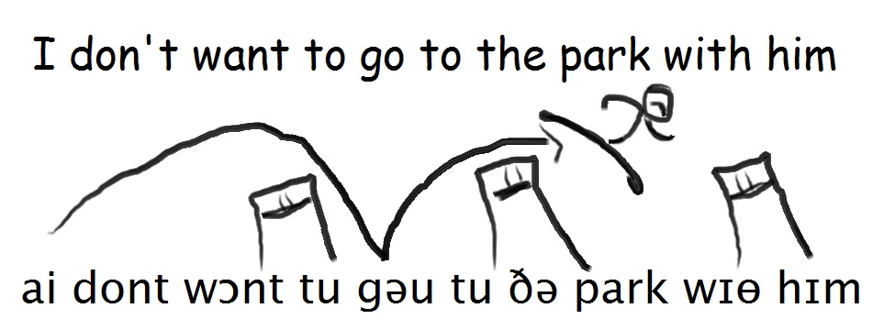
pronuncing all of the word completely is difficult to say and difficult to understand.
Native speakers skip parts of words to save time and energy
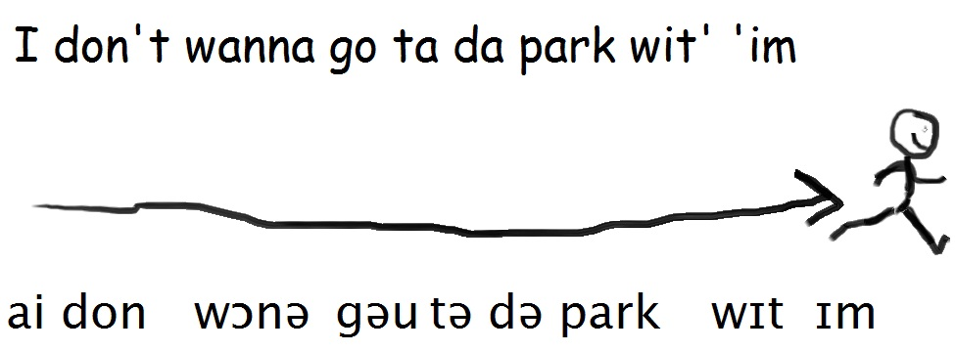
really common words that don't add meaning to the sentence tend to be skipped.

The => də in => n and => n for => fɚ of => ə or => r to=> tə can=>cn

Recognition: what word is really being said?

- It's n da bag. 1) It's ______ ________ bag.
- Da fish n' chips r cold. 2) ____ fish _____ chips ______cold.
- I forgot ta shut da door. 3) I forgot ____ shut _____door.
- Is it black r blue? 4) Is it black _____ blue?
- Let's go n da house. 5) Let's go ______ _____ house.
- It's a pile a cars. 6) It's a pile ______ cars.
- What n da world? 7) What ______ _____ world?
- I'm sick n tired a that. 8) I'm sick ____ tired ____ that.
- That was out a da blue. 9) That was out ____ ____ blue.
- He's off ta da bank. 10) He's off __ ___ bank.
- Was is da big guy r da little guy? 11) Was it __ big guy ___ ___ little guy.
- That's a kick n da teeth. 12) That's a kick ___ ___ teeth.
- It was lost n translation. 13) It was lost ___ translation.
- There's some nuts n bolts. 14) There's some nuts ____ bolts.
- Where's da salt n pepper? 15) Where's ___ salt ___ pepper?
- Time fer a change. 16) Time _____ a change.
- Two fer a dollar. 17) two ____ a dollar.
- What a load a crap. 18) What a load ____ crap.

Pronouns with h or th (he,him,his,hers,her,them) occur in almost every sentence, so “h” and “th” are cut.

him => /ɪm/ her => /ɚ/ his => /ɪz/ he => /i/ them => /əm/ or /m/
Also, words that end in -ing get reduced to /n/ or /ən/
working => /wɚk.n/ falling => /fal.n/ or /falən/ letting => /lɛtn/ or rather /lɛɾn/*
applies to verbs with -ing and also to “Nothing” and “Something.”

- Tell im da truth. 1) Tell him the truth
- I can't stand im. 2) I can't stand ______.
- It's not er boat. 3) It's not ____ boat.
- I told er ta come. 4) I told _____ ______ come.
- I'm er secretary. 5) I'm _____ secretary.
- He put is money where is mouth is. 6) He put _____ money where ______ mouth is.
- He bit off more than e cn chew. 7) ______ bit off more than _____ _____ chew.
- I already saw em. 8) I already saw _____.
- We found em on da ground. 9) We found ______ on the ground.
- If you can't beat em, join em. 10) If you can't beat ______, join _______.
- Somethin about im makes me nervous. 11) ______ about ______ make me nervous.
- It's gettin on my nerves 12)
- Nothin like a good spankin 13)
- We're hopin e comes 14)
- There's somethin n da soup. 15)
- Is e stayin r leavin? 16)
- Thanks fer nothin 17)
Let's review with some questions:
- Are reductions for written English or for Spoken English?
- Do you have to try to use reductions whenever you speak English?
- Are reductions going to be useful for you?

would =>ʊd or => əd are => r would have =wʊdə should have => ʃʊdə could have => kʊdə

- I wish someone ud clean up n here. 1) I wish someone would clean up in here.
- what r da codes fer da new lock? 2)
- I woulda killed im if e'd said it. 3)
- You idiot! You coulda been killed! 4)
- What ud e do if she got n trouble? 5)
- There r two kinds a people n da world. 6)
- No one would've expected im ta come. 7)
- You shoulda woken em up n time. 8)
Important distinction! The reduction of “have” happens when there is another verb after it.
- I thought we would have seen it => I thought we wʊdə seen it (“Seen” is a verb.)
- I thought we would have a concert => “would have” is not reduced

- because there is no other verb. You can reduce it to “we'd have” or “we ʊd have”
Identify the proper usage of reductions which sentences reduce and which ones don't?
- Mom said I could have a cookie => 1) not reduced
- I would have sworn I had it when I left => 2) reduced to wʊdə
- You should have a better attitude. => 3)
- I knew someone would have a key here. => 4) *can reduce to “someone ʊd”
- I should have written down her number => 5)
- You think someone could have stolen it?=> 6)
- If it were true I would have heard about it. 7)
- This problem could have several solutions. 8)
- You think you should have kissed her, eh? 9)
- Of all the people, only you could have. 10)

want to=>wɔnə going to=>gənə have to=>hæftə has to=>hæstə
got to=>gɔtə=> gɔɾə* must have=>məstə don't know=>dənou

- I don't wanna go ta da park with im. 1) I don't want to go to the park with him
- I'm gonna finish this project today. 2)
- We hafta be quiet now: it's past bed-time. 3)
- Someone hasta clean up da livin room. 4)
- I've gotta go. 5)
- I musta left it n da car. 6)
- I dunno where e went r why e left. 7)
- Does someone wanna tell me who did it? 8)
- We've all gotta try harder 10)
Rules for “going to”
The “to” is absorbed by the “going.” They become one word
Only reduce when there is another verb after it.
--I'm going to kill him => I'm gənə kill him. (“Kill” is a verb.)
--I'm going to class => I'm goin ta class. (No verb, but the -ing and the “to” can be shortened.)
Identify where to reduce try identifying the other verb.
- I'm going to go home => 1) I'm gonna go home. (there's a verb)
- We finally got to class => 2) We finally got ta class. (No verb after “to.”)
- I must have one of those. => 3) I must have one ə those. (No verb after “have.”)
- We're going to party like it's 1999 => 4) we're gonna party like it's 1999. (“Party” is a verb.)
- We're going to a party. => 5) We're goin to a party. (“a party” is NOT a verb.)
- Somethings got to give here. 6)
- They're going to the chapel 7)
- They must have switched the tapes 8)
- I think he's going to say something. 9)
the rules:
- only reduce verbs with “to” if followed by another verb.
- only reduce verbs with “have” if followed by another verb.
you => jə your => jər you're => jər
- Yer not savin im, yer drownin im! 1) You're not saving him; you're drowning him!
- I saw ya talkin to im. 2)
- He has yer key n is pocket. 3)
- Yer gonna wanna see this fer yerself. 4)
Important new rule
“you, ” “you're,” “your” after a word that ends with -d, turns into the sound /dƷ/ and makes one word.
- I heardja were back n town. 1) I heard you were back in town.
- Someone foundjer wallet. 2)
- He saidjer leavin soon. 3)
- I'm gladjer feelin better. 4)
Another rule just like it
after a word that ends with -t, the y becomes a tʃ and make one word.
- He'll never letcha drive is car now. 1)
- I forgotcher tickets. 2)
- Izzatcher boat? 3) Is that your boat?
- nobody butchoo likes that song. 4)

“did you,” =>dƷə“dja.” wh- words +did you =>wh-dja “do you” =>dəjə “daya.”
- Howdja know e was comin? 1) How did you know he was coming?
- Howdja get n da buildin? 2)
- Whendja last call im? 3)
- Whodja ask ta da dance? 4)
- Whydja hafta kill em all? 5)
- Whadja say to im? 6)
- Whadja say ta him? 7)
- Whadaya wanna eat fer dinner? 8)

Here are some more important rules
if you speak faster, you reduce more words. You don't reduce all possible words.
--what did you do to him? => wədƷə du: tu: m “to” is not reduced, “him” is
-------OR wədƷə du: tə hɪm “to” is reduced, but “him” is not.
- He came fayour money 1)
He came for yermoney.
- I fown the tickets fathem. 2)
I founda tickets forem.
- We're takin care ovis fees. 3)
We're takin care a his fees.
some words can be reduced at the end of a sentence.
- We got nothing => reduce to “nothin”
- I got you => reduce to gɔtʃə “Gotcha”
- Someone's coming => reduce to “comin”
The other words DON'T reduce
- This letter is for you => don't reduce “you”
- He doesn't want to => don't reduce “want to”
- What's he waiting for? => don't reduce “for”
- I thought it was his => don't reduce “his”
One last rule about flaps. There's a special sound called “flap.”: ɾ. It's not an r.
“t” or “d” spoken quickly become flap.
- Not yet => nɔɾ jɛɾ
- Last night =>
- I forgot =>
Ends of sentences.
If the last thing you say is a p,t or k, it is unreleased. Your mouth stays closed when you say the p,t or k.
practice these
- it's never going to stop =>
- I saw him this week =>
- Everything is alright =>

Thomas: Hey, Mark, I betcha I cn jump over that pile a bricks.
Marcus: No ya can't.
Thomas: Whadaya wanna bet I can't do it?
Marcus: Um...I bet you yer transformer you can't do it.
Thomas: I betchoo your transformer I can.
(Thomas goes to jump over the bricks.)
Marcus: Wait, no! Mine is new than yours. Yers is dirty andja pulled one a the legs off already.
Thomas: Too late!
(Thomas starts running toward the bricks.)
Marcus: Mom! Tommy's gonna jump over da bricks!
(Dianne comes out just as Thomas over the pile. He lands on his face and hands. He starts crying.)
Dianne: OK, Tommy, why doncha come back n our yard.
Thomas: I can't mommy! I got hurt jumpin' da brick? Waaaaaaaaahhhhhh!
Dianne: Yes, I think you can. Yer a big boy. You cn do it. Come back over here.
Thomas: Mark hasta gimme 'is transformer. He said I couldn't do it.
Marcus: No I don't! You cheated! I never saidja could have it!
Thomas: Yes you did! You bet me my transformer. That means you hafta bet your transformer!
Dianne: Thomas, are you allowed ta go n da other yard?
Thomas: Mommy, my hands hurt.
Dianne: I understand your hands hurt, Dear. Are you allowed ta go n that other yard?
Thomas: Thomas. Is that true? Are you tellin the truth? Come on, are you allowed over there?
Marcus: He's not! You said we're not s'posta go n the other yard!
Dianne: Marcus, I don't needju ta talk about the rules. I need Tommy to remember da rules.
Thomas: No, we're not allowed ta go over there.
Dianne: Why daya think you're not allowed ta go there? What happened when you went there?
Thomas: I hurt my hands. Will you fix em now, Mommy?
Dianne: No. Not when you get hurt disobeying. I think you cn go wash yer hands n put on the ointment n bandaids by yourself. Mark, you cn go inside, too. I think you two need ta be quiet fer a while.
1) How old do you think Marcus and Thomas are? Who do you think is older?
2) What are the alternative names for Marcus and Thomas?

3) How many things did Dianne do? Did you agree with some of the things she did?

Personality Type

What kind of person are you? How do you think?
Introvert/Extrovert Intuitive/Thinking
Feeling/Thinking Perceiving/Judging
This is a very basic overview of the Meyers-Briggs personality types
Here are some words you need to know

Some Important Information: 1) In this case, the words mean something different from what they usually mean, so if you try to look them up in the dictionary, it won’t help. 2) There is no best personality types, it is just your natural preference.
How do you get energy?
Introverts Extroverts
Like thinking Like doing things
Knowing a lot about a few things know a little about a lot of things
Quality Time with people seeing people often
Use energy being with people Gain energy being with people

H
How do you make decisions?
ThinkingFeeling
Detachedharmonious
Logicalneeds of the
Following rulespeople involved
“outside” the situation“Inside” the situation
How do you get information?
SensingIntuitive
Trust what you can trust ideas and
See, hear, feelpossibilities that
Taste and smellcan relate to other ideas
What is the lifestyle system and how does it work?
Perceivers Judges
Prefer to use their sensing or intuition Prefer to use their thinking or feeling

Are you an Introvert or an Exrovert?
I think that…
Everyone sees the best part of me The best part of me is hidden from the world
I like working in groups I like working alone or with my best friend.
I like doing several things for a short time. I like doing one thing for a long time.
I like to understand things by doing them. I like to think and read about things first.
I like sharing my opinions with others. I don’t like sharing emotions or opinions.
I have many friends. I have few friends but we are very close.
I think while talking. I think before I talk.
I like when other people get involved. I don’t like other people to get involved.
I say what I am thinking without being asked. I don’t say what I’m thinking unless asked.
I get more energy by being with people. It takes energy to be with people.
I like parties with lots of friends. I like being by myself.

Advertisement Project

The final exam will be a group project
You and your group have formed an imaginary company and you must present an advertisement for your company.

--everyone works together on the advertisement
--everyone speaks during the advertisement
--You must sell your product or service

